ASSIGNMENT 6

By: Olasubomi Borishade

Department of Electrical Engineering
University of North Texas, Discovery Park

EENG 3910.001 – Embedded System Design Project
Dr. Xinrong Li & Masleh Uddin Siddiqui
October 23rd, 2023
Table of Contents

Introduction…………………………………………………………………………
Problem, Results & Discussion ……………………………………………………
Conclusion……………………………………………………………………….…
References……………………………………………………………………….…

Introduction

In our EENG 3910 class, students have been introduced to the concept of embedded systems design using STM32 development tools by STMicroelectronics. We are coding using the C programming language and utilizing specific functions that interface with our Nucleo Board.

In our last lecture, the focus topic was Pulse-Width Modulation (PWM). The previous labs and lectures focused on ADC/DAC, so our focus on PWM is coherent, as PWM can be described as a way digital pulses can control analog signals. PWM is likened to a form of modulation in which the carrier signal is digital, and the message/information is analog. The PWM method is used in applications where we’d like to control the average power delivered to a load. This application is achieved by switching the amplitude of a digital signal (pulsating) between a high and low state with a switching period/frequency high enough that the load doesn’t recognize/get affected by it. The power output of the analog signal delivered to the load only changes when the digital pulse is high, creating the effect of the analog signal being sampled/quantized.

The frequency of the PWM is determined by the ‘duty cycle’. The duty cycle describes the proportion of time the signal is in its high state in comparison to its low state. For example, when the signal is high for the same amount of time it is low; we call that a 50% duty cycle. The percentage value widely chosen is that for the time spent on: if the signal is high for 25% of the time, we call it a 25% duty cycle. The internal clock that generates these digital pulses determines the rate at which the signal switches between the on and off state. The quicker the time, the smoother the load control (to an extent). The slower it is, the more likely it is to create oscillations in the output of the load (e.g., visible flickering in an LED).

Pulse-width modulation is used in controlling the speed of electric motors, regulating the brightness of LEDs (as we will see in today’s assignment), encoding messages, audio amplification, etc. In this week’s lab, we will utilize the internal clock system in our MCU to generate a PWM waveform and adapt it to control the luminosity of an LED. I’ve attached all the codes with this submission for ease of verification.

Problem, Results & Discussion

To begin with any problem, we had to follow the getting started document as the default setting for our Nucleo Board. We did this for every new problem.

Problem 1
The first task we were to undertake was the generation of a PWM waveform. This project was adapted from the project on page 308 of the textbook. Using the internal clock source and timer capabilities, we were to generate a PWM waveform whenever the LED was flashing. We included the same USART capabilities from all our previous labs; using PuTTY, we should be able to control the duty cycle of our PWM and set up a test circuit where we can visually see the effects of these changes on an oscilloscope. Here’s the code we received from Dr. Li:

/*
* app6_1.c
*
* Created on: Oct 9, 2023
* Author: ojb0020
*/

/* Includes ------------------------------------------------------------------*/
#include "stdio.h"
#include "stdlib.h"
#include "string.h"

#include "stm32l4xx_hal.h"
#include "app.h"

/* Private define ------------------------------------------------------------*/
#define LED_PORT GPIOA
#define LED_PIN GPIO_PIN_5

#define LED_MODE_OFF 0
#define LED_MODE_ON 1
#define LED_MODE_FLASHING 2

#define PWM_DUTYCYCLE_MAX 100
#define PWM_DUTYCYCLE_MIN 0
#define PWM_DUTYCYCLE_STEP 5

/* Private function prototypes -----------------------------------------------*/
void ShowCommands(void);
void UART_TransmitString(UART_HandleTypeDef *p_huart, char a_string[], int newline);

void PWM_SetDutyCycle(float dutyCycle);

/* Extern global variables ---------------------------------------------------------*/
extern TIM_HandleTypeDef htim2;
extern TIM_HandleTypeDef htim3;

extern UART_HandleTypeDef huart2;

//Should be declared as volatile if variables' values are changed in ISR.
volatile char rxData; //One byte data received from UART
volatile int ledMode = LED_MODE_FLASHING;

volatile float pwmDutyCycle = 50.0;

void App_Init(void) {
HAL_GPIO_WritePin(LED_PORT, LED_PIN, GPIO_PIN_SET);

UART_TransmitString(&huart2, "-----------------", 1);
UART_TransmitString(&huart2, "~ Nucleo-L476RG ~", 1);
UART_TransmitString(&huart2, "-----------------", 1);

ShowCommands();

HAL_TIM_Base_Start_IT(&htim3);
HAL_UART_Receive_IT(&huart2, (uint8_t*) &rxData, 1); //Start the Rx interrupt.

HAL_TIM_PWM_Start(&htim2, TIM_CHANNEL_2);
PWM_SetDutyCycle(pwmDutyCycle);
}

void App_MainLoop(void) {

}

void HAL_TIM_PeriodElapsedCallback(TIM_HandleTypeDef *p_htim) {
if (p_htim == &htim3) {
if (ledMode == LED_MODE_FLASHING) {
HAL_GPIO_TogglePin(LED_PORT, LED_PIN);
}
}
}

void PWM_SetDutyCycle(float dutyCycle) {
uint16_t periodValue, compareValue;

periodValue = __HAL_TIM_GET_AUTORELOAD(&htim2);
compareValue = periodValue * dutyCycle /100.0;
__HAL_TIM_SET_COMPARE(&htim2, TIM_CHANNEL_2, compareValue);
}

void HAL_UART_RxCpltCallback(UART_HandleTypeDef *p_huart) {
//Process the data received from UART.
switch (rxData) {
case 'I':
case 'i':
HAL_GPIO_WritePin(LED_PORT, LED_PIN, GPIO_PIN_SET);
ledMode = LED_MODE_ON;
break;
case 'O':
case 'o':
HAL_GPIO_WritePin(LED_PORT, LED_PIN, GPIO_PIN_RESET);
ledMode = LED_MODE_OFF;
break;
case 'F':
case 'f':
ledMode = LED_MODE_FLASHING;
break;
case 'H':
case 'h':
ShowCommands();
break;
case 'P':
case 'p':
pwmDutyCycle += PWM_DUTYCYCLE_STEP;
if (pwmDutyCycle > PWM_DUTYCYCLE_MAX) {
pwmDutyCycle = PWM_DUTYCYCLE_MAX;
}
PWM_SetDutyCycle(pwmDutyCycle);
break;
case 'M':
case 'm':
pwmDutyCycle -= PWM_DUTYCYCLE_STEP;
if (pwmDutyCycle < PWM_DUTYCYCLE_MIN) {
pwmDutyCycle = PWM_DUTYCYCLE_MIN;
}
PWM_SetDutyCycle(pwmDutyCycle);
break;
}

HAL_UART_Receive_IT(p_huart, (uint8_t*) &rxData, 1); //Restart the Rx interrupt.
}

void ShowCommands(void) {
UART_TransmitString(&huart2, "Type on keyboard to send command from PC to MCU:", 1);
UART_TransmitString(&huart2, "> I: turn on LED, O: turn off LED, F: flashing LED, H: show commands", 1);
UART_TransmitString(&huart2, "> P: increase PWM duty cycle, M: decrease PWM duty cycle", 1);
}

void UART_TransmitString(UART_HandleTypeDef *p_huart, char a_string[], int newline) {
HAL_UART_Transmit(p_huart, (uint8_t*) a_string, strlen(a_string), HAL_MAX_DELAY);
if (newline != 0) {
HAL_UART_Transmit(p_huart, (uint8_t*) "\n\r", 2, HAL_MAX_DELAY);
}
}

Here’s a picture of the boards pins which are connected to the oscilloscope:

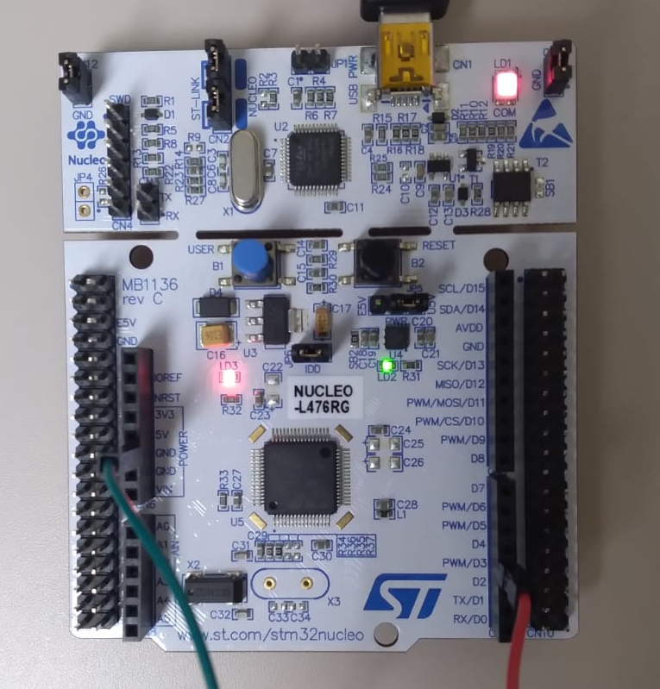

To verify that the serial PuTTY commands work, here are images of our oscilloscope with different duty cycles:
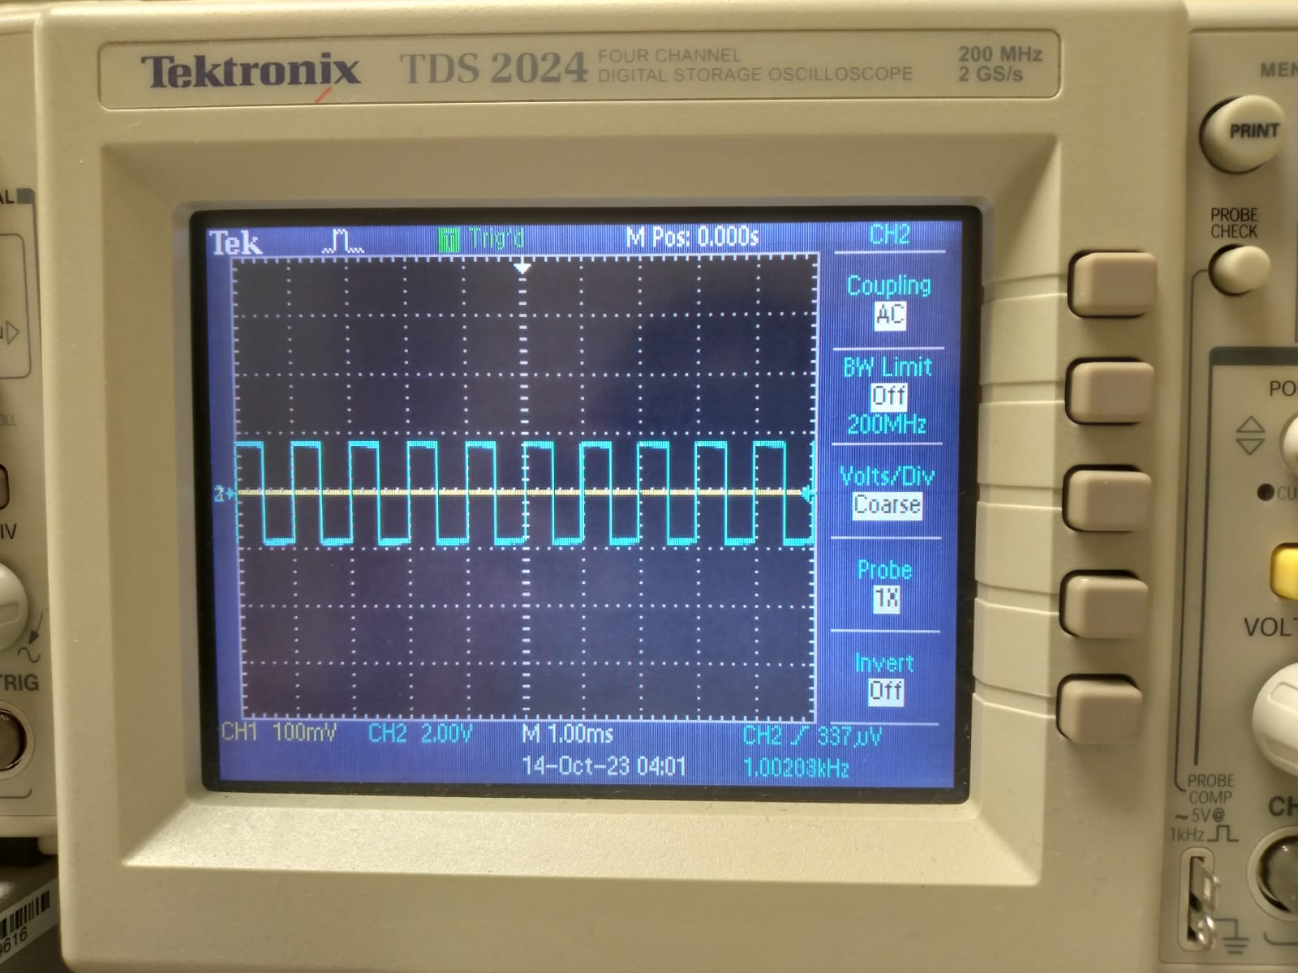

The default PWM duty cycle is 50%, giving us a basic square wave with equally high and low state timing. Each state retains for a total of 0.5 milliseconds. The period is 1 millisecond. Using the equation
$f=\frac{1}{T}$,
we get that our frequency is 1kHz.

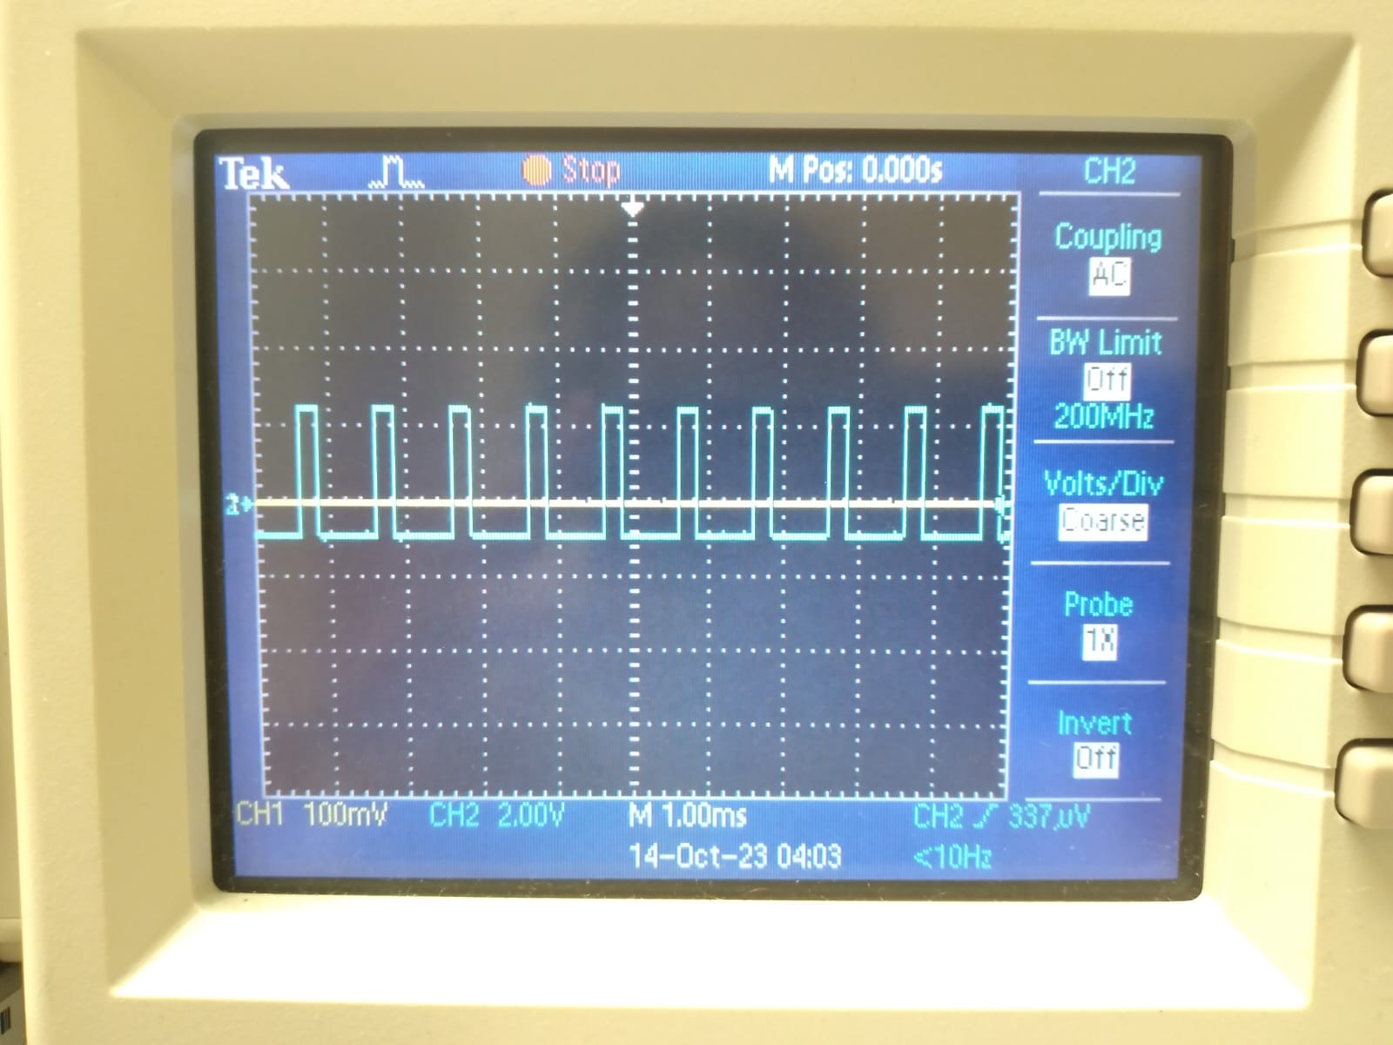

Problem 2
For the second task, we used the first problem’s code as a foundation to make an LED dimmer; this is one of the major ways PWM signals are used. We needed to implement an interrupt with TIM3 to drive the heartbeat LED on the pin PA5. We were then required to output the PWM signal on PB3 as in Problem and adjust the duty cycle of the PB3 PWM signal using the keyboard command as in Problem 1.

The main functionality of the code is configured with code developed to output the PWM signal on PA15 with a duty cycle complementary to the PWM signal
on PB3; that is, PA15_dutycycle = 100 – PB3_dutycycle. With such implementation, when we increase the duty cycle of the PB3 PWM signal using the keyboard command, the duty cycle of pin PA15’s PWM signal will decrease, and vice versa. This ensures that the other increases when one signal increases in average power. This is how the LEDs are dimmed or increased. Here is the code used for this function:

/*
* app6_2.c
*
* Created on: Oct 13, 2023
* Author: ojb0020
*/

/* Includes ------------------------------------------------------------------*/
#include "stdio.h"
#include "stdlib.h"
#include "string.h"

#include "stm32l4xx_hal.h"
#include "app.h"

/* Private define ------------------------------------------------------------*/
#define LED_PORT GPIOA
#define LED_PIN GPIO_PIN_5

#define LED_MODE_OFF 0
#define LED_MODE_ON 1
#define LED_MODE_FLASHING 2

#define PWM_DUTYCYCLE_MAX 100
#define PWM_DUTYCYCLE_MIN 0
#define PWM_DUTYCYCLE_STEP 5

/* Private function prototypes -----------------------------------------------*/
void ShowCommands(void);
void UART_TransmitString(UART_HandleTypeDef *p_huart, char a_string[], int newline);

void PWM_SetDutyCycle(float dutyCycle);

/* Extern global variables ---------------------------------------------------------*/
extern TIM_HandleTypeDef htim2;
extern TIM_HandleTypeDef htim3;

extern UART_HandleTypeDef huart2;

//Should be declared as volatile if variables' values are changed in ISR.
volatile char rxData; //One byte data received from UART
volatile int ledMode = LED_MODE_FLASHING;

volatile float pwmDutyCycle = 50.0;

void App_Init(void) {
HAL_GPIO_WritePin(LED_PORT, LED_PIN, GPIO_PIN_SET);

UART_TransmitString(&huart2, "-----------------", 1);
UART_TransmitString(&huart2, "~ Nucleo-L476RG ~", 1);
UART_TransmitString(&huart2, "-----------------", 1);

ShowCommands();

HAL_TIM_Base_Start_IT(&htim3);
HAL_UART_Receive_IT(&huart2, (uint8_t*) &rxData, 1); //Start the Rx interrupt.

HAL_TIM_PWM_Start(&htim2, TIM_CHANNEL_2);
HAL_TIM_PWM_Start(&htim2, TIM_CHANNEL_1);
PWM_SetDutyCycle(pwmDutyCycle);
}

void App_MainLoop(void) {

}

// Use TIM3 interrupt to drive the heart beat of the LED on the pin PA5.
void HAL_TIM_PeriodElapsedCallback(TIM_HandleTypeDef *p_htim) {
if (p_htim == &htim3) {
if (ledMode == LED_MODE_FLASHING) {
HAL_GPIO_TogglePin(LED_PORT, LED_PIN);
}
}
}

void PWM_SetDutyCycle(float dutyCycle) {
uint16_t periodValue, compareValue, PA15_dutycycle, complementaryValue;

//Output PWM signal on PB3 as in Problem 1
periodValue = __HAL_TIM_GET_AUTORELOAD(&htim2);
compareValue = periodValue * dutyCycle /100.0;
__HAL_TIM_SET_COMPARE(&htim2, TIM_CHANNEL_2, compareValue);

// Output PWM signal on PA15 with a duty cycle that is complementary to the PWM signal on PB3
PA15_dutycycle = PWM_DUTYCYCLE_MAX - dutyCycle; //

PA15_dutycycle = 100 – PB3_dutycycle
complementaryValue = periodValue * PA15_dutycycle /100.0;
__HAL_TIM_SET_COMPARE(&htim2, TIM_CHANNEL_1, complementaryValue);

}

void HAL_UART_RxCpltCallback(UART_HandleTypeDef *p_huart) {
//Process the data received from UART.
switch (rxData) {
case 'I':
case 'i':
HAL_GPIO_WritePin(LED_PORT, LED_PIN, GPIO_PIN_SET);
ledMode = LED_MODE_ON;
break;
case 'O':
case 'o':
HAL_GPIO_WritePin(LED_PORT, LED_PIN, GPIO_PIN_RESET);
ledMode = LED_MODE_OFF;
break;
case 'F':
case 'f':
ledMode = LED_MODE_FLASHING;
break;
case 'H':
case 'h':
ShowCommands();
break;
case 'P':
case 'p':
pwmDutyCycle += PWM_DUTYCYCLE_STEP;
if (pwmDutyCycle > PWM_DUTYCYCLE_MAX) {
pwmDutyCycle = PWM_DUTYCYCLE_MAX;
}
PWM_SetDutyCycle(pwmDutyCycle);
break;
case 'M':
case 'm':
pwmDutyCycle -= PWM_DUTYCYCLE_STEP;
if (pwmDutyCycle < PWM_DUTYCYCLE_MIN) {
pwmDutyCycle = PWM_DUTYCYCLE_MIN;
}
PWM_SetDutyCycle(pwmDutyCycle);
break;
}

HAL_UART_Receive_IT(p_huart, (uint8_t*) &rxData, 1); //Restart the Rx interrupt.
}

void ShowCommands(void) {
UART_TransmitString(&huart2, "Type on keyboard to send command from PC to MCU:", 1);
UART_TransmitString(&huart2, "> I: turn on LED, O: turn off LED, F: flashing LED, H: show commands", 1);
UART_TransmitString(&huart2, "> P: increase PWM duty cycle, M: decrease PWM duty cycle", 1);
}

void UART_TransmitString(UART_HandleTypeDef *p_huart, char a_string[], int newline) {
HAL_UART_Transmit(p_huart, (uint8_t*) a_string, strlen(a_string), HAL_MAX_DELAY);
if (newline != 0) {
HAL_UART_Transmit(p_huart, (uint8_t*) "\n\r", 2, HAL_MAX_DELAY);
}
}

Connect the oscilloscope to PB3, GND, and PA15 and GND of your Nucleo board to monitor the two PWM signal outputs. Here’s an image of the oscilloscope and our LED circuit breadboard through 470 Ω resistors, showing both signals in their default state:

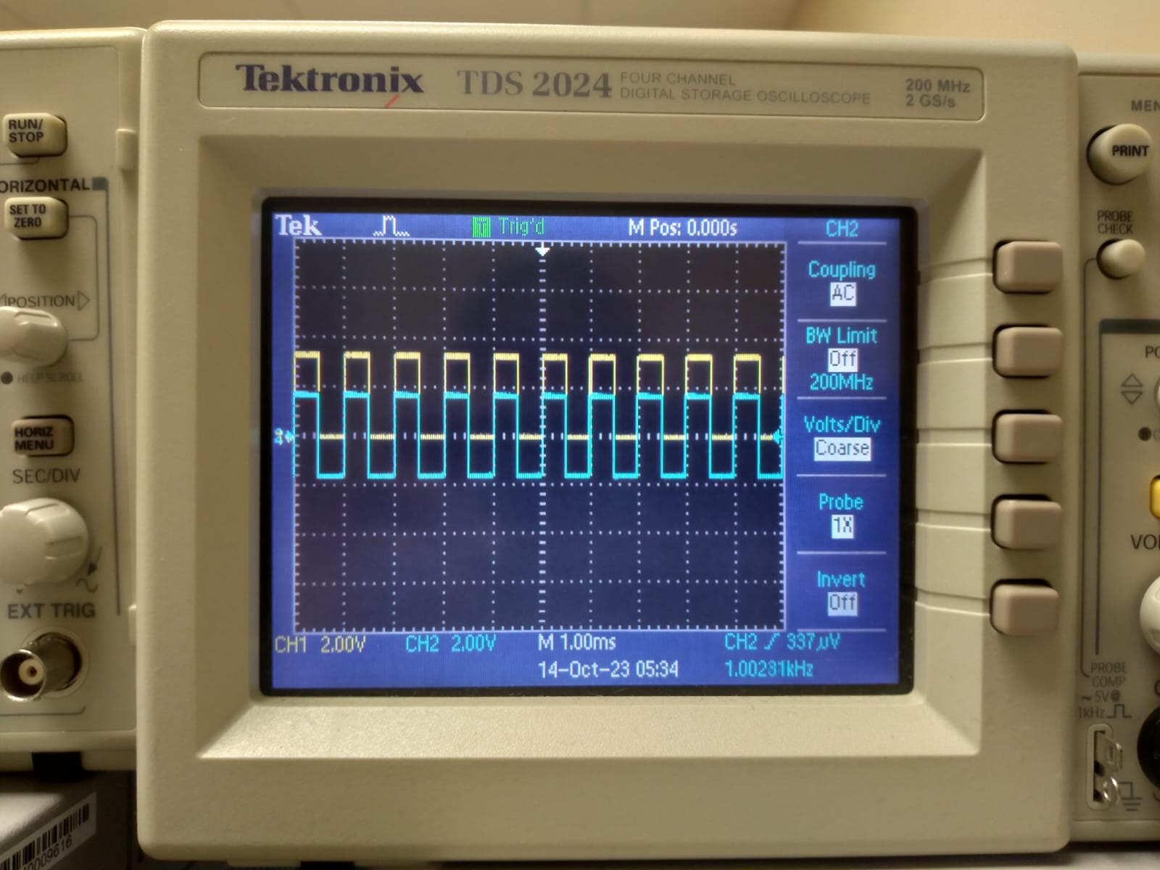

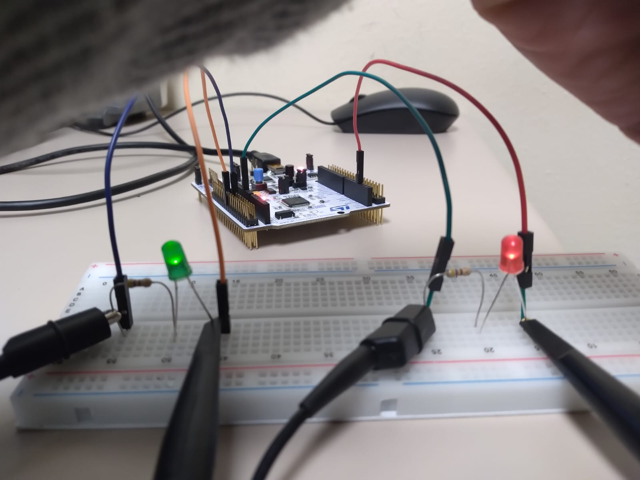

Using the USART command functions we coded on PuTTY; we can control the duty cycle of both signals complementarily. Here are images showing a 100% (and simultaneously, 0% for the other), making one of the LEDs on and the other off:
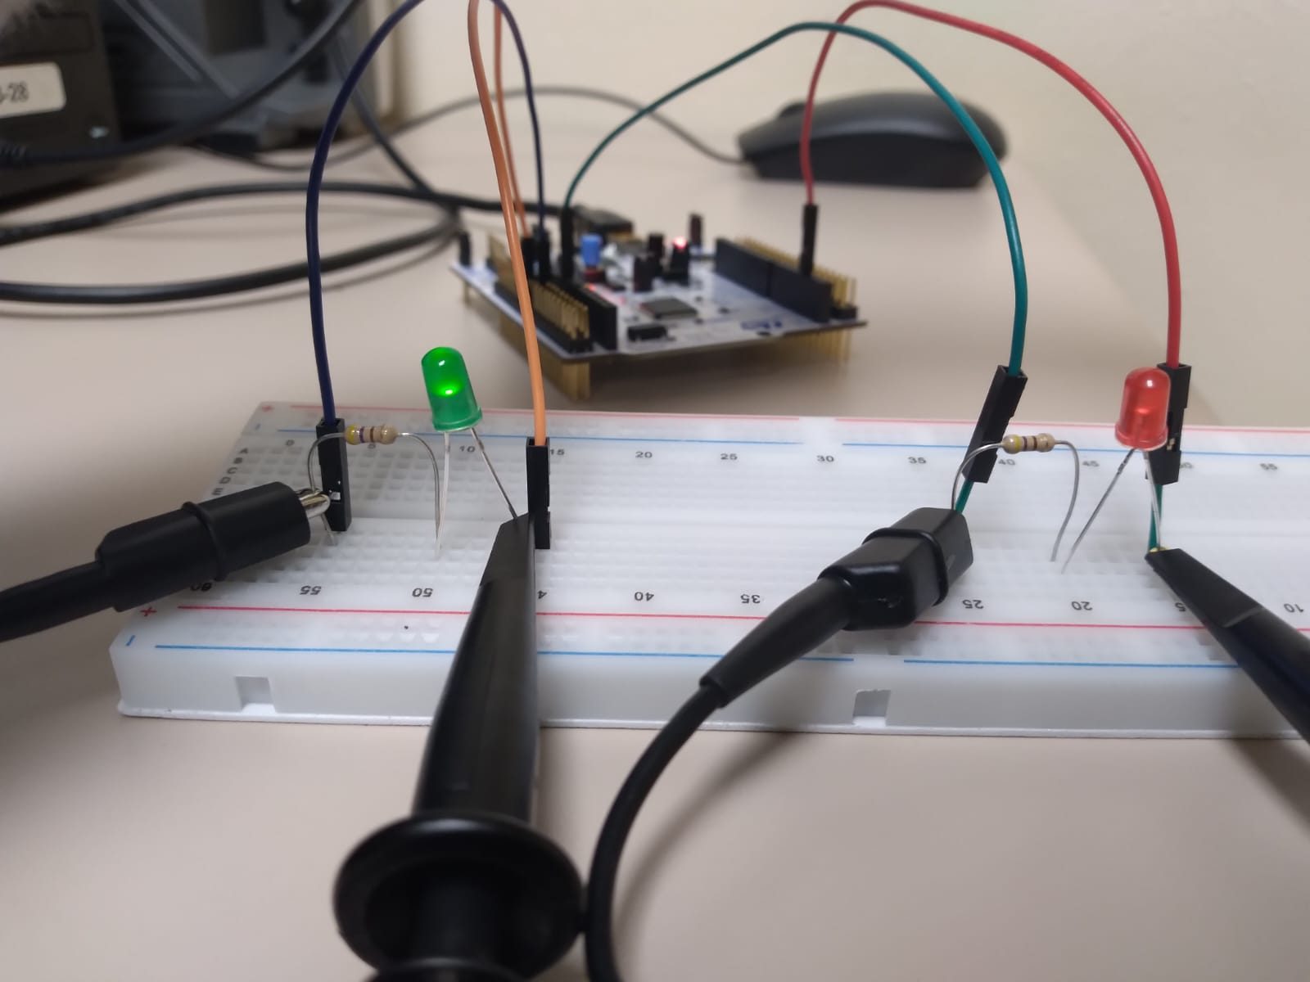

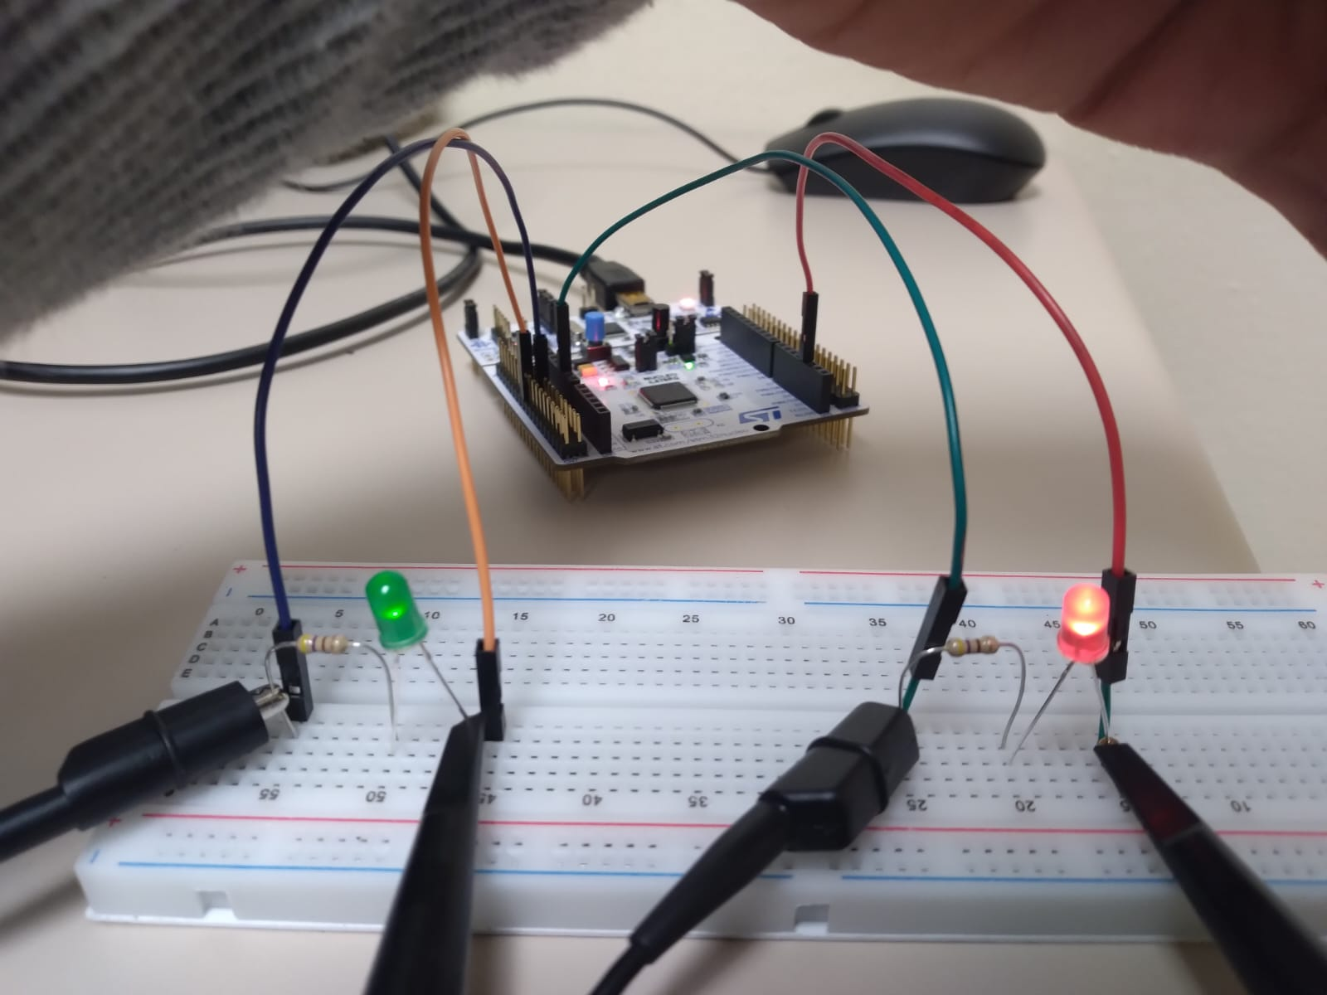

Summary & Conclusion

In this assignment, I learned about PWM signals. I learned specifically about how the duty cycles can be controlled using counter periods and pre-scaler values in the STM32CubeIDE. I also implemented a passthrough from the analog-to-digital converter to the digital-to-analog pinout on the Nucleo board.

References

[1] Heath, J., PWM: Pulse width modulation: What is it and how does it work?, August 2nd, 2023. https://www.analogictips.com/pulse-width-modulation-pwm/

